Longest Subarray with sum k:

Optimal Approach:

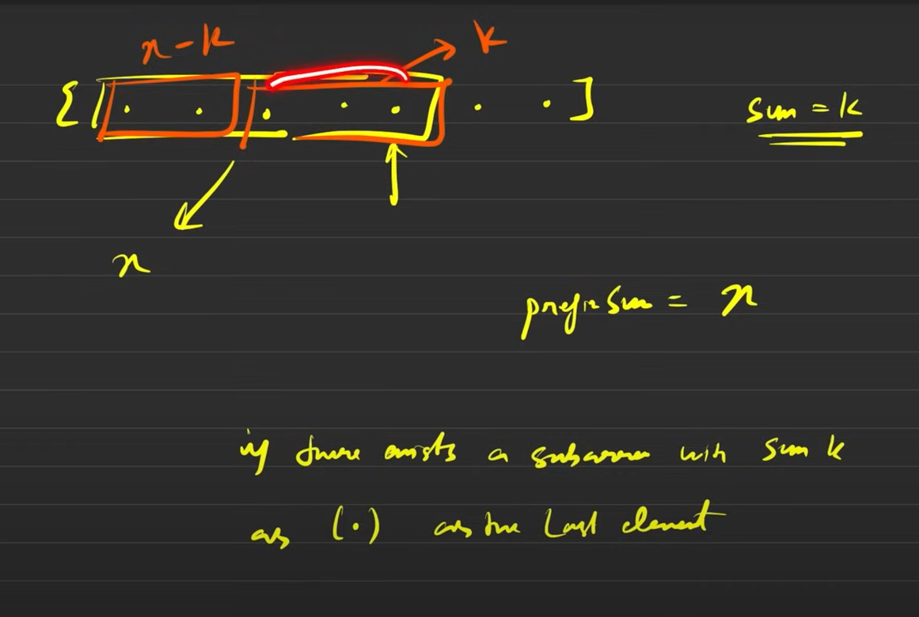

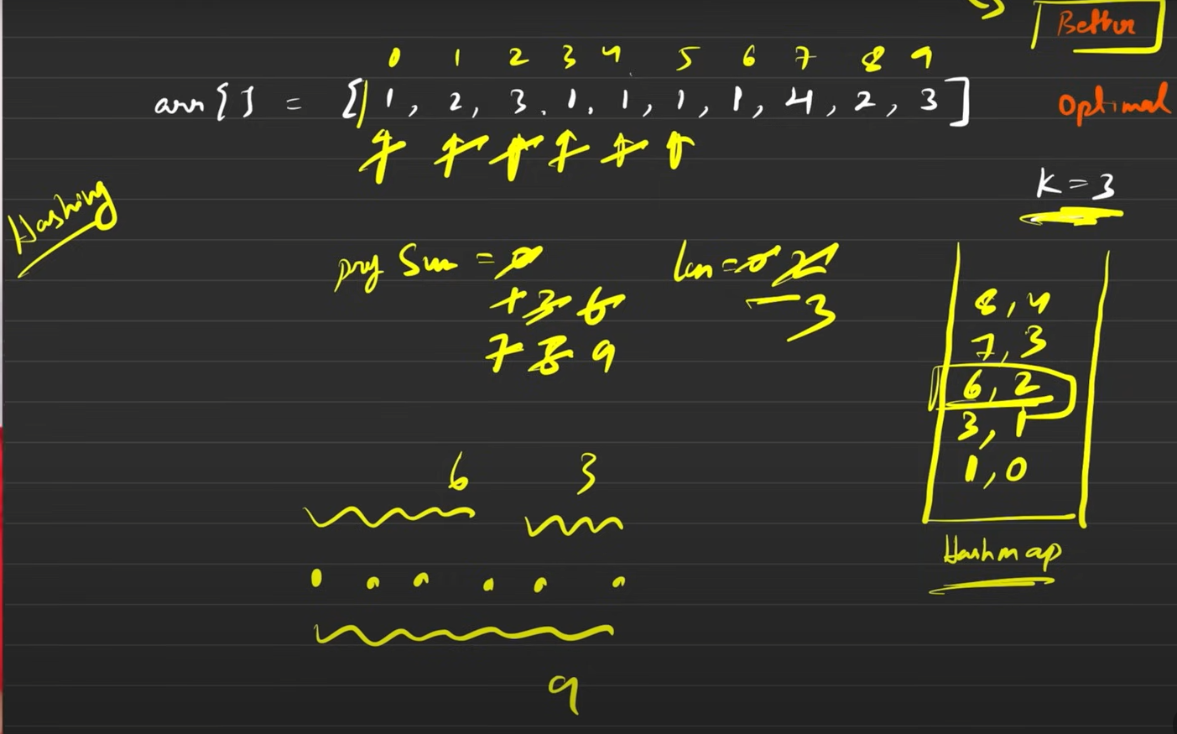

**Problems on array:**

**Swap an array of 0s, 1s and 2s=> Optimal Approach ( Dutch Flag algorithm)  
